**Advance Database Management Systems Lab**

**Lab Test**

**Aryan Mohan**

**500091978**

**Batch- 2**

create database LabTest;

use LabTest;

create table Library(BookID varchar(4) not null, BookName varchar(55) not null, Author varchar(45), DatePurchased Date, Publisher varchar(25), Price int);

insert into Library values('B101', 'Cost Accounting', 'Jain Narang', '11-Feb-13', 'Kalyani', 80);

insert into Library values('B102', 'Business Statistics', 'OP Aggarwal', '22-Dec-11', 'Himalaya', 750);

insert into Library values('B103', 'Rdbms', 'C J Date', '2-Mar-15', 'TMH', 900);

insert into Library values('B104', 'Mgmt Accounting', 'RK Sharma', '19-Apr-16', 'Kalyani', 450);

insert into Library values('B105', 'Operating Systems', 'Galvin', '25-Nov-13', 'PHI', 750);

insert into Library values('B106', 'Advanced Accounting', 'SC Gupta', '16-Apr-18', 'Himalaya', 600);

--Write sql query to display the list of authors from Himalaya publications.

select Author from Library where Publisher='Himalaya';

Output:



--Write sql query to display the total cost of books purchased Publisher wise.

select sum(Price) from Library group by Publisher;

Output:

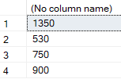

--Write sql query to count the total number of books under Kalyani publications.

select count(BookName) from Library where Publisher='Kalyani';

Output:



--Write sql query to rename the column Publisher as Publications.

exec sp_rename 'Library.Publisher', 'Publications', 'COLUMN';

select * from Library;

Output:

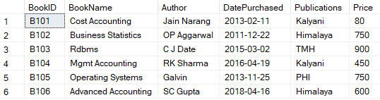

--Write a sql query to display the books in the ascending order of DatePurchased.

select BookName from Library order by DatePurchased;

Output:

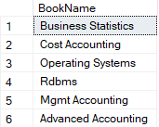

--Write sql query to create an index on the fields BookName and Author.

create index INDEX1 on Library (BookName, Author);

Output:



--Write sql query to display the books whose price is between 500 and 700

select BookName from Library where Price>=500 and Price<=700;

Output:



--Write sql query to increase the price of all the books by 200 for publishers other thanHimalaya or Kalyani.

update Library set Price = Price + 200 where Publications NOT IN ('Himalaya', 'Kalyani');

select * from Library;

Output:

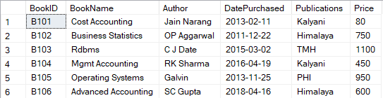

--Write sql query to display the book details where author name contains the name Sharma.

select * from Library where Author like '%Sharma';

Output:



--Create a view to display the fields BookId and BookName where the Publisher isHimalaya.

CREATE VIEW HimalayaBooks AS SELECT BookID, BookName FROM Library WHERE Publications = 'Himalaya';

SELECT * FROM HimalayaBooks;

Output:

